CSCE 313 Programming Assignment 0

Aldo Leon Marquez UIN: 326004699

The Purpose of the assignment was to recap some concepts of c++ and to introduce us to setup and use a linux environment to compile and debug the given code and for future assignments during the course. The assignment consists of a code that had some bugs that we were to find and solve.

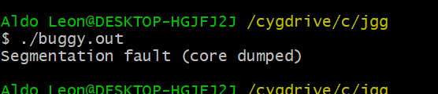(**4)** After solving the first few exercises, we encounter a segmentation fault when first trying to run the .out file:

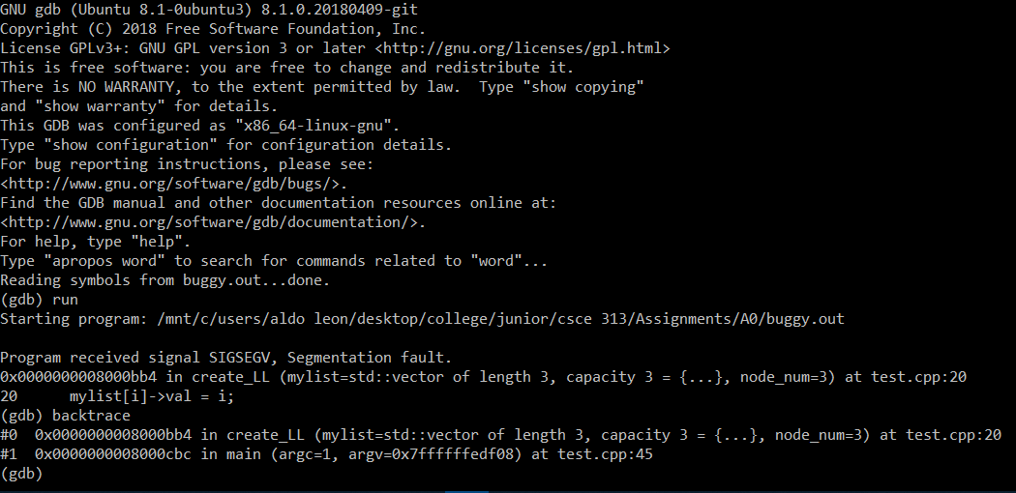(**6**) Then the gdb is used to start solving the bugs that prevent the program from running:

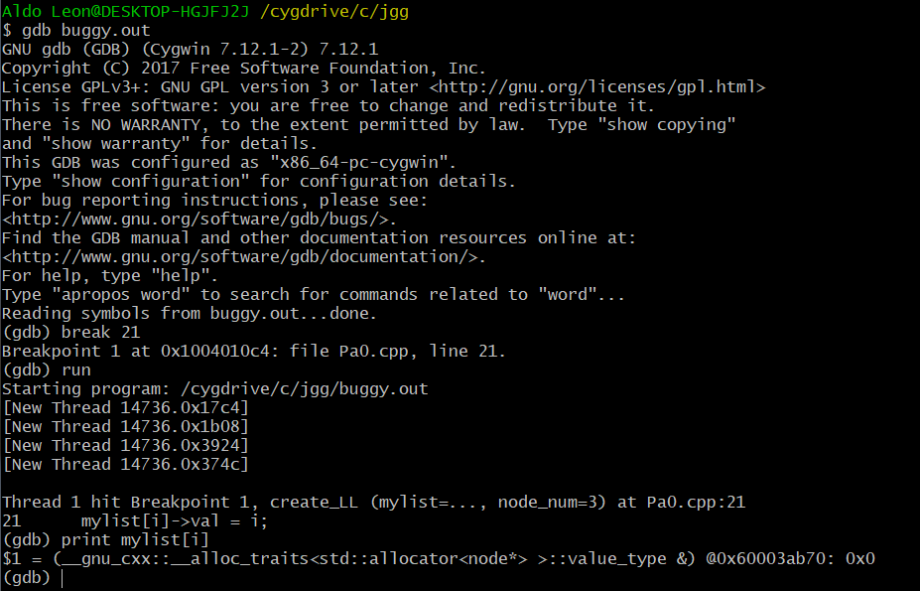(**7**) Now that we know in what line the error is. By printing the stored value the issue becomes clear, the pointer stores in the vector is pointing to address 0x0;

(**9**) The lst segmentation fault we encounter has to do with how the for loop is setup when creating the node list, the loop runs one to many times so it tries to access an out of index pointer, causing the segfault.

(**10**) The make sure the nodes were deleted and no memory leaks occur I implemented a for loop that runs for the final size of the vector, assigning the “next” pointers to Null and then erasing the pointer itself from the vector. A valgrind check for memory leaks confirms that no leak occurred.

